

School of InfoComm Technology

Data Virtualization
Diploma in Data Science (DS)
2025 Oct Semester

INDIVIDUAL ASSIGNMENT
(40% of Module)

09 Jan 2026 – 01 Feb 2026

Deadline for Submission:
Denodo Database File, Report and PowerPoint Slides: 01 Feb 2026 (Sun), 2359hrs

Student Name | : | Jayden Tee Rong Qing
Student Number | : | S10267542D

Penalty for late submission:
10% of the marks will be deducted every day after the deadline.
NO submission will be accepted after 08 Feb 2026, 23:59.

Table of content
Table of Contents
School of InfoComm Technology 1
Table of content 2
Overview of Table of Content 3
1. Introduction with Value based Problem Statement 4
Exploratory Questions 4
2. Data Source and Base View 6
Creation of Database and Loading to Denodo 6
Configuration and Rationale/Explanation behind uses of Data sources 8
Rational behind use of data sources 9
Configuration and Rationale/Explanation behind uses of Base View 10
Data Standardization 10
Rationale behind use of base view: 13
3. Feature Engineering and Derived/Integrated Views 13
iv_inventory_status 14
Iv_sales_enriched 15
Iv_sales_master 17
4. Final Integrated View 19
rv_regional_supply_chain 19
Joining Logic 19
Contributing CSV file and Reasoning 20
Dimension Design 21
How does these fields answer the exploratory question? 22
5. REST or SOAP Deployment 24
Rationale of web service choice 24
REST Service Configuration 25
Web Service Configuration 26
Security 26
Deployment of Service 27
Preview output 28
6. Summary and Further Improvements 29
Summary of Findings 29
Reflection on Deployment 29
Key learning outcomes 29
Further Improvements 30

Overview of Table of Content
This report documents the development of a virtualized Inventory-to-Sales reporting solution using Denodo. It first opens with a value-based problem statement addressing operational blind spots in supply chain management and identifying key stakeholder needs, followed by a description of the nine underlying CSV data sources and the base views created to standardize demand, supply, and demographic datasets. Next, it explains how integrated views and engineered measures were designed to combine disparate orders, inventory, product, and staff information into business-ready intelligence. The report then presents the final reporting view, detailing the grouping dimensions and calculated performance metrics used to analyze turnover efficiency, aging inventory risks, and regional profitability. Finally, the report demonstrates how the final RV is deployed as a REST web service to enable lightweight, secure consumption by downstream applications, and concludes with reflections on the virtualization process and recommendations for further improvements.

1. Introduction with Value based Problem Statement

In today’s fast-paced retail ecosystem, optimizing the balance between inventory availability and customer demand is the definitive factor in sustaining good profitability and brand loyalty. In this case, for a bicycle retail company operating across different geographic locations, supply chain data is frequently stored from customer relationship records and transactionsal data. For example, inventory levels are tracked in Stocks tables, while demand signals are stored in Orders and Order Items and demographic data sits in Customer records. When these datasets are analyzed alone, management could suffers from a “ data blind spot ” regarding how inventory delays impacts regional revenue or customer retention. This error forces reliance on manual cross-referencing, which leads to missed sales opportunities or an inability to better reallocate stock to meet shifting demands.

The primary stakeholders I selected for this use case are the Chief Operations Officer (COO) , Regional Supply Chain Managers, and Store Operations Leads. The COO requires a macro-level view of "Supply vs. Demand" health to approve high-level inventory procurement strategies. While, Regional Managers need detailed store-level visibility to prevent stockouts of highly demanded products and execute restocks effectively. Store Operations Leads are interested in comparing "Lost Sales" risks with high-value customers, ensuring that premium clients are not driven to competitors due to local unavailability. Although these stakeholders approachs the data from different prespectivities, they all require a unified real-time virtualization of the supply chain that bridges the gap between what is on the shelf and who is trying to buy it.

The value-based problem addressed in this assignment is the lack of an integrated "Inventory-to-Sales" performance view that connects stock availability with transactional volume and customer value. Without this integration, stakeholders cannot determine if revenue drops are caused by poor sales performance or simply a lack of inventory and that organization relies on manual cross-referencing that is too slow for agile decision
making. Using Denodo, this solution applies data virtualization to federate live inventory data with historical sales and customer demographics. This creates reusable real-time views that enable proactive inventory balancing and customer identification without the overhead of physical data consolidation.

Exploratory Questions:
To ensure the virtualized dataset delivers meaningful business value, the following exploratory questions guide the design of the data views:

- How does inventory sufficiency correlate with regional sales performance?
Rationale: To distinguish between sales performance issues and supply chain constraints.
- Which specific products and categories face the highest risk of "Stockout" relative to their sales velocity?
Rationale: To trigger immediate re-ordering for high-demand items.
- What is the volume of "Aging Inventory" (older model years) across different regions?
Rationale: To inform liquidation strategies for depreciating assets (e.g., 2016 models).
- How are high-value customers distributed across regions, and are they serviced by stores with adequate inventory levels?
Rationale: To identify churn risks where VIP demographics overlap with low stock availability.
- Which brands demonstrate the highest "Turnover Efficiency" (Sales Quantity / Stock Quantity) per store?
Rationale: To optimize future shelf-space investment based on return on inventory.

2. Data Source and Base View

Creation of Database and Loading to Denodo
The assignment folder given has a total of 9 CSV files which represents the bicycle retailers’s core sales and production entities. 5 of the CSV files represents the sales operational data, which are customers, staff, orders, stores and order items and the other 4 CSV file represents the production operational data which are categories, products, stocks and brands as stated on the kaggle site.

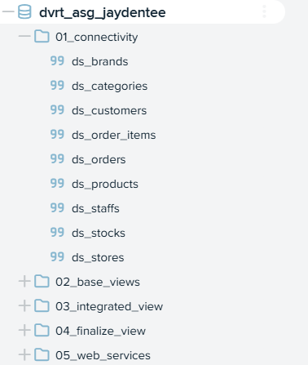
Figure 1. Denodo databases and folder structures for assignment
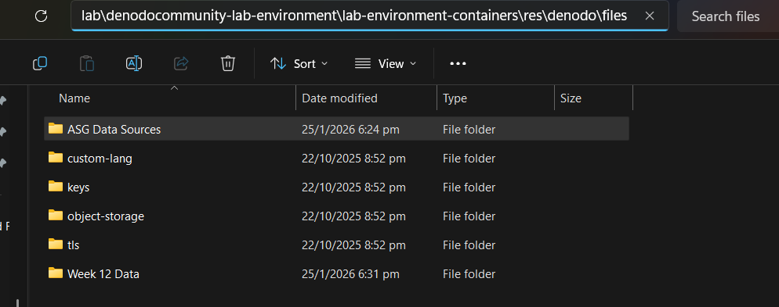
Figure 2. Assignment folder with CSV files placed into the Denodo lab environment folder

Firstly, I created a dedicated Denodo database (dvrt_asg_jaydentee) with a clear folder structure to separate:
- 01_connectivity – CSV data source connections
- 02_base_views – Standardized base views
- 03_integrated_views – Derived and joined views
- 04_finalize_views – Final reporting view
- 05_web_service – REST/SOAP deployment

These files were also placed before creating the database into the Denodo lab environment to ensure consistent access and repeatability during development and integration.

Configuration and Rationale/Explanation behind uses of Data sources

For each CSV file, it follows a similar naming format where it is registered as, datasources (ds_) CSV name (e.g. brands) (ds_brands) using the Denodo delimited file (CSV) connector. Additionally, key file settings such as delimiter being set to ‘,’ and enabling headers were verified to prevent any schema misreads.

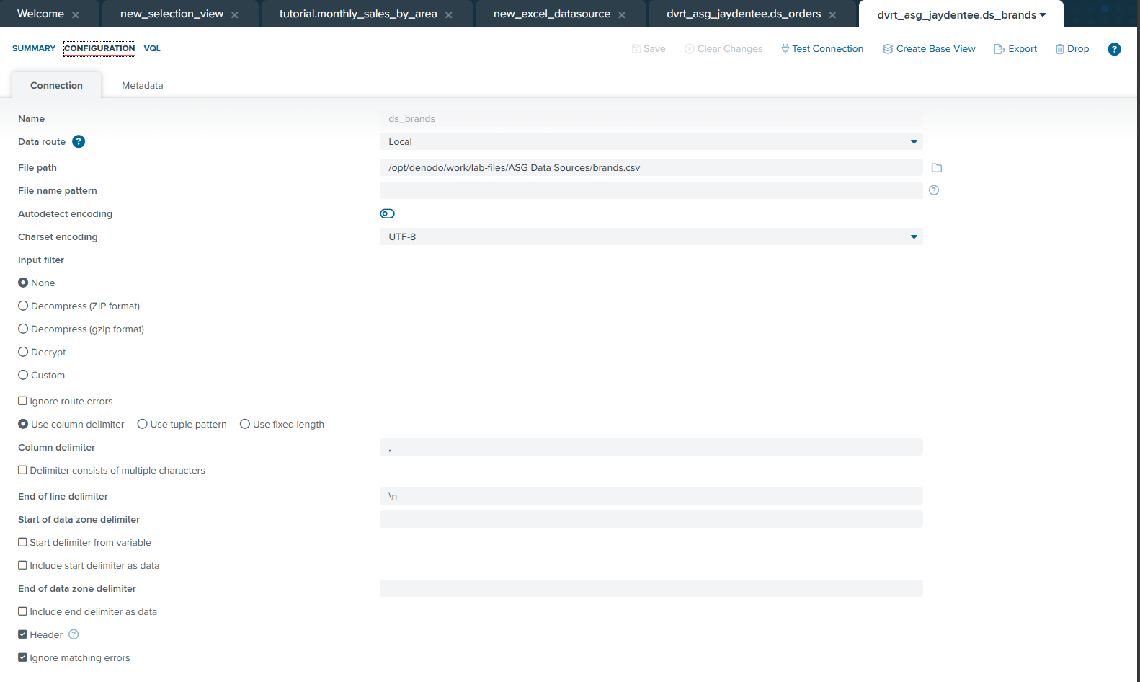
Figure 3. Configuration used to creating a CSV datasource in Denodo (brands.csv)

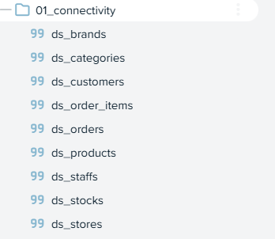
Figure 4. CSV datasources used and successfully created in Denodo

Rational behind use of data sources
In my case, I loaded the entire ecosystem of the business (9 CSV), as if I had left even one file out, it would have created a "data blind spot" as stated in my problem statement. Hence, this list explains the reasoning behind loading every CSV to better understand going forward.

- orders.csv and order_item.csv
- Rationale: These files provides the transactional history required to calculate sales volume and revenue.
- Link to problem statement: It allows to distinguish whether a product is not moving because of low sales or low availability.

- stock.csv
- Rationale: This contains the live inventory counts for every product at every store.
- Link to problem statement: To identify stockout risks or quantify the volume of aging inventory.

- customers.csv
- Rationale: This provides the geographic location of buyers.
- Link to problem statement: Addresses the "Customer Retention" goal by enabling us to map VIP customers against store inventory.

- products.csv
- Rationale: This acts as the central dictionary, containing critical metadata like Model Year and List Price.
- Link to problem statement: It provides the model_year field, which is the only way to automate the detection of "Aging Inventory".

- stores.csv
- Rationale: This groups data by physical location.
- Link to problem statement: It enables the "Regional Supply Chain" analysis, allowing the stakeholder to compare performance across cities.

- brands.csv & categories.csv
- Rationale: These provide human-readable groupings (e.g., "Trek”) for the raw product ID.
- Link to problem statement: It allows stakeholder to make high-level procurement decisions at the Brand/Category level rather than just the SKU (Stock Keeping Unit) level.
- staffs.csv
- Rationale: This links transactions to specific employees.
- Link to problem statement: It ensures the architecture is future-proofed for operational accountability, ensuring we can trace successful inventory turnover back to effective store management.

Configuration and Rationale/Explanation behind uses of Base View
For each datasource, a corresponding base view (bv_*) was created so as define the schema, data type and establish the contract to the datasource so as to enable joining and analysis. (Figure 5)

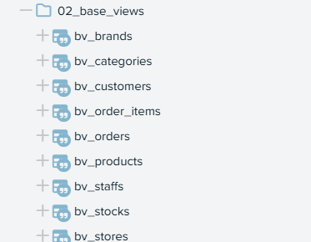
Figure 5. Base view created from each datasource

Data Standardization
After creating each base view, I reviewed the schemas and adjust some of the fields for standardization so that later, joins and aggregration calculations behave correctly.

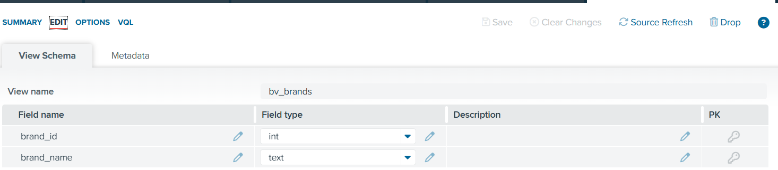
Figure 6. Base view schema: bv_brands

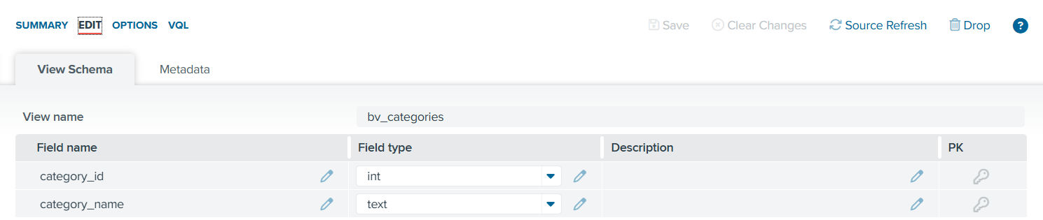
Figure 7. Base view schema: bv_categories

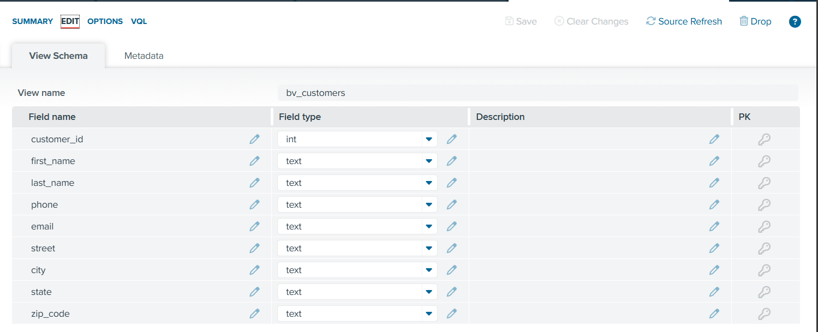
Figure 8. Base view schema: bv_customers

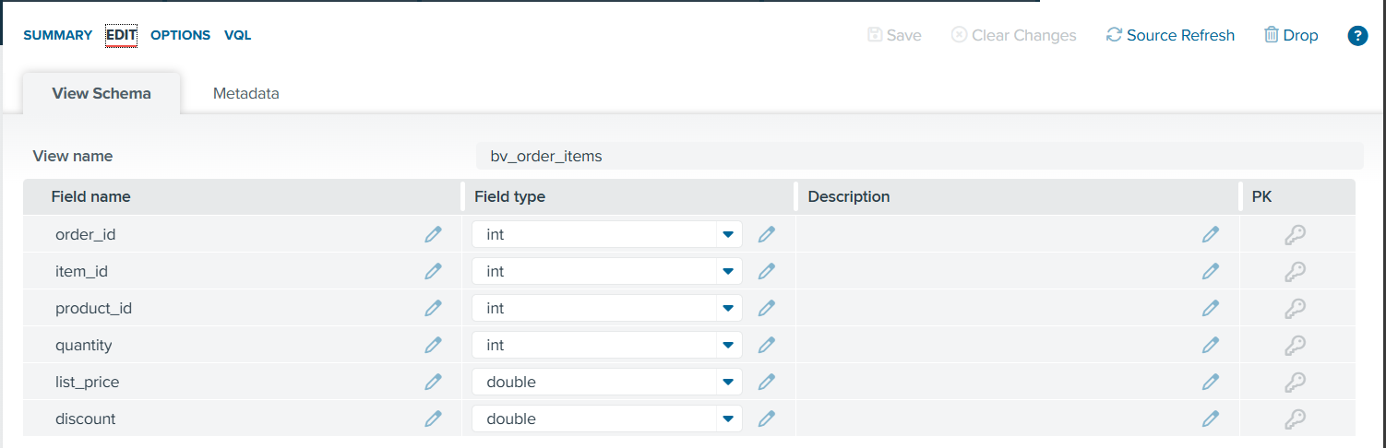
Figure 9. Base view schema: bv_order_items

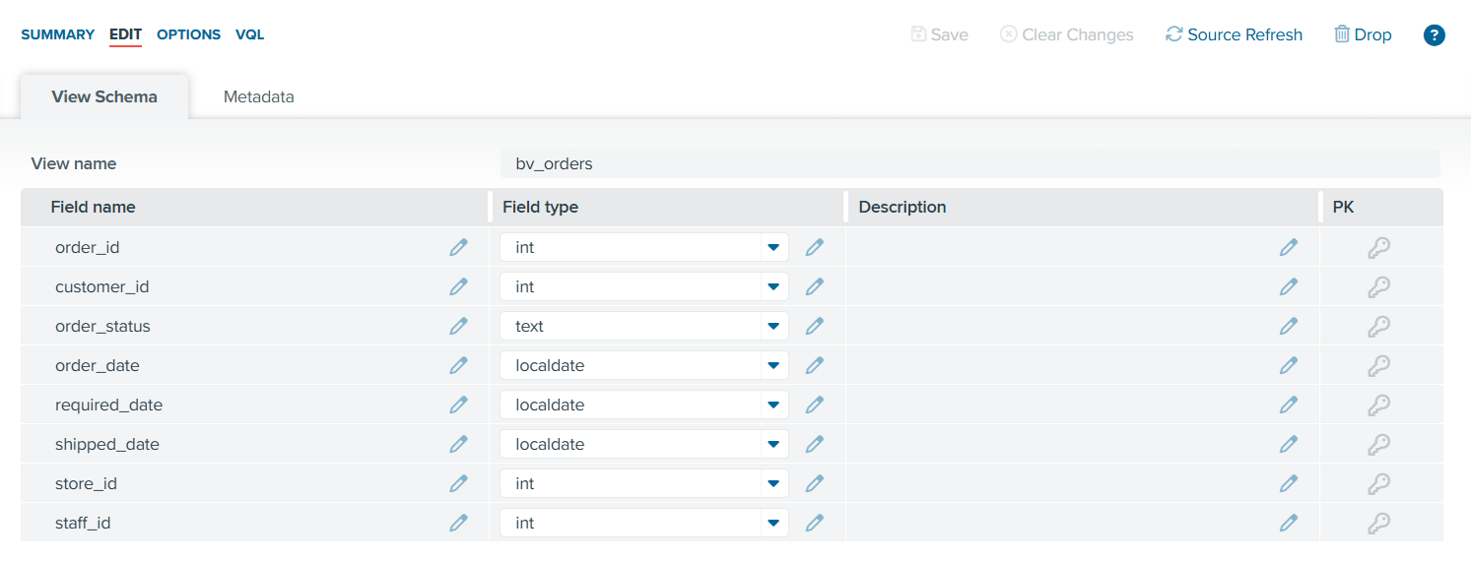
Figure 10. Base view schema: bv_orders

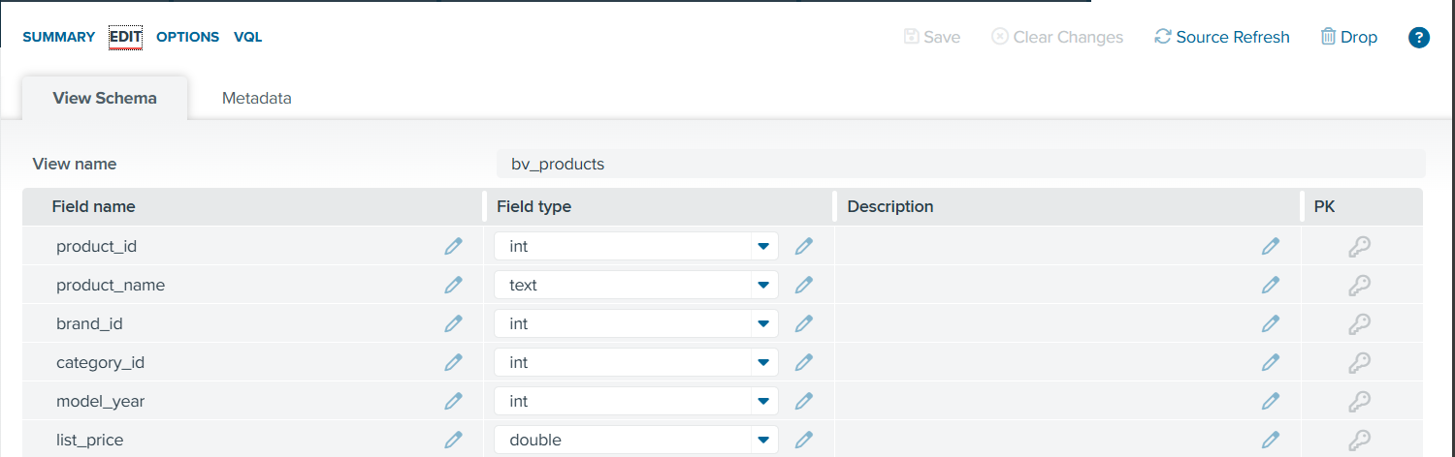
Figure 11. Base view schema: bv_products

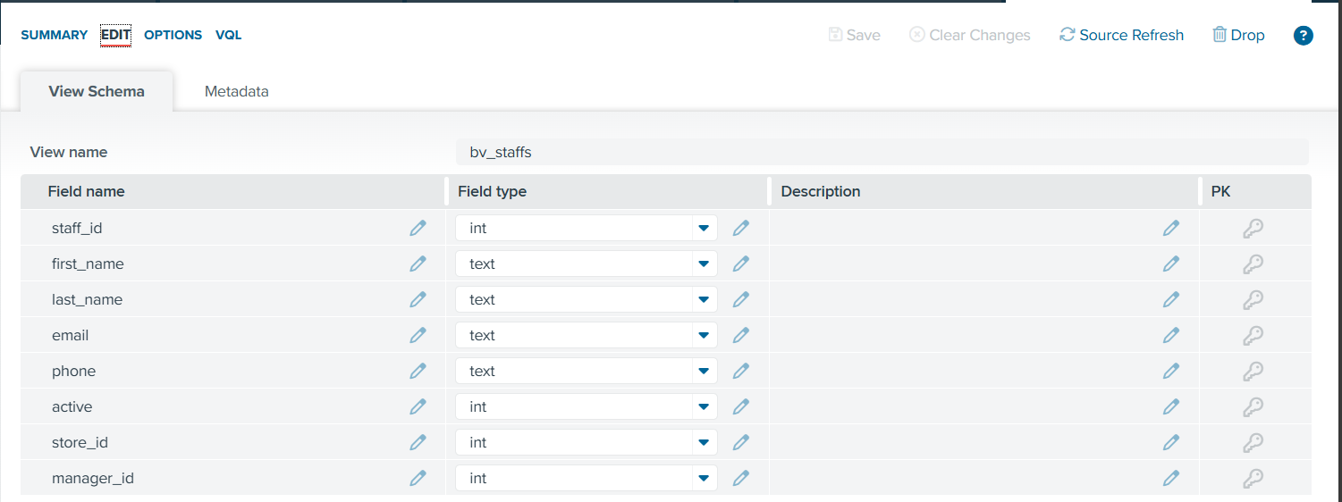
Figure 12. Base view schema: bv_staffs

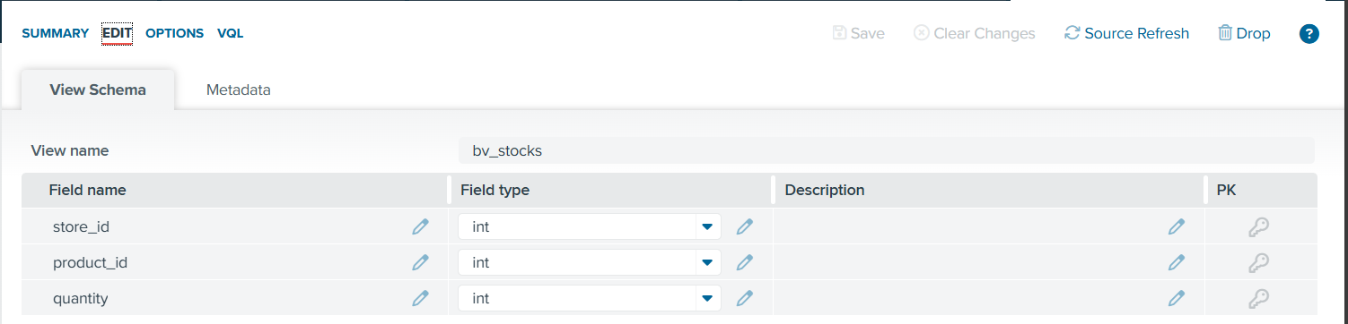
Figure 13. Base view schema: bv_stocks

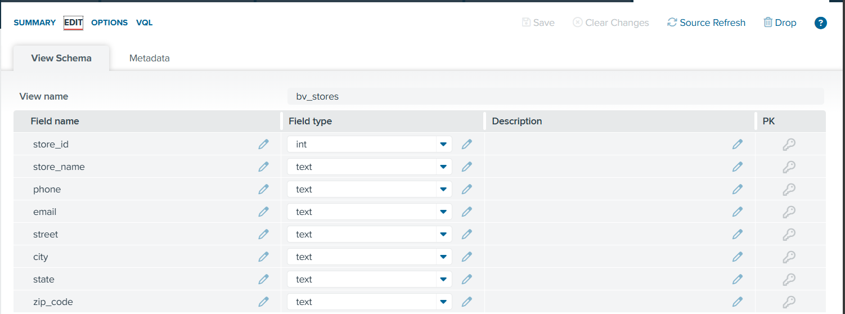
Figure 14. Base view schema: bv_stores

Rationale behind use of base view:
The implementation of standardized base views is essential to preserve referential integrity across integrated datasets. This strategy ensures consistent join keys such as order_id and category_id, thereby minimizing data redundancy, improving auditability, and ensuring the scalability of the reporting architecture.

3. Feature Engineering and Derived/Integrated Views
To transform the base views into actionable business insights and address the exploratory questions defined in the problem statement, several integrated views were engineered through the combination of base view. This approach gives each integrated view a clear purpose linking to the stakeholder.

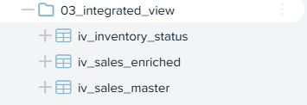
Figure 15. Overview of integrated views

iv_inventory_status
Overview/Rationale
This view constructs the "Supply Engine" by solving the location problem, it joins the stocks fact table with the stores dimension using the key store_id and stock fact table with the product dimension using the key product_id. Inner joins were utilized to ensure that inventory data is always associated with a valid physical operating location. Hence, standardizing the supply grain, adding critical geospatial context like Store Name, State to raw stock counts to enable regional availability analysis.

Feature Engineering
Stock_value -> The total financial capital tied up in unsold inventory.
- Formula => (bv_stocks.quantity*bv_products.list_price)
- Reasoning => This is a Cost metric, which quantifies the liability
Stock_status -> A categorical label derived from stock_quantity
- Formula => case WHEN (bv_stocks.quantity = 0) THEN 'OUT OF STOCK' WHEN (bv_stocks.quantity < 5) THEN 'CRITICAL LOW' WHEN (bv_stocks.quantity >= 25) THEN 'OVERSTOCK' ELSE 'HEALTHY' END
- Reasoning => This field automates the manual check. Instead of a manager scanning 5,000 rows for the number "0", this feature acts as an automatic alert system, instantly flagging the "Critical" items that cause the blind spots mentioned in the problem statement.

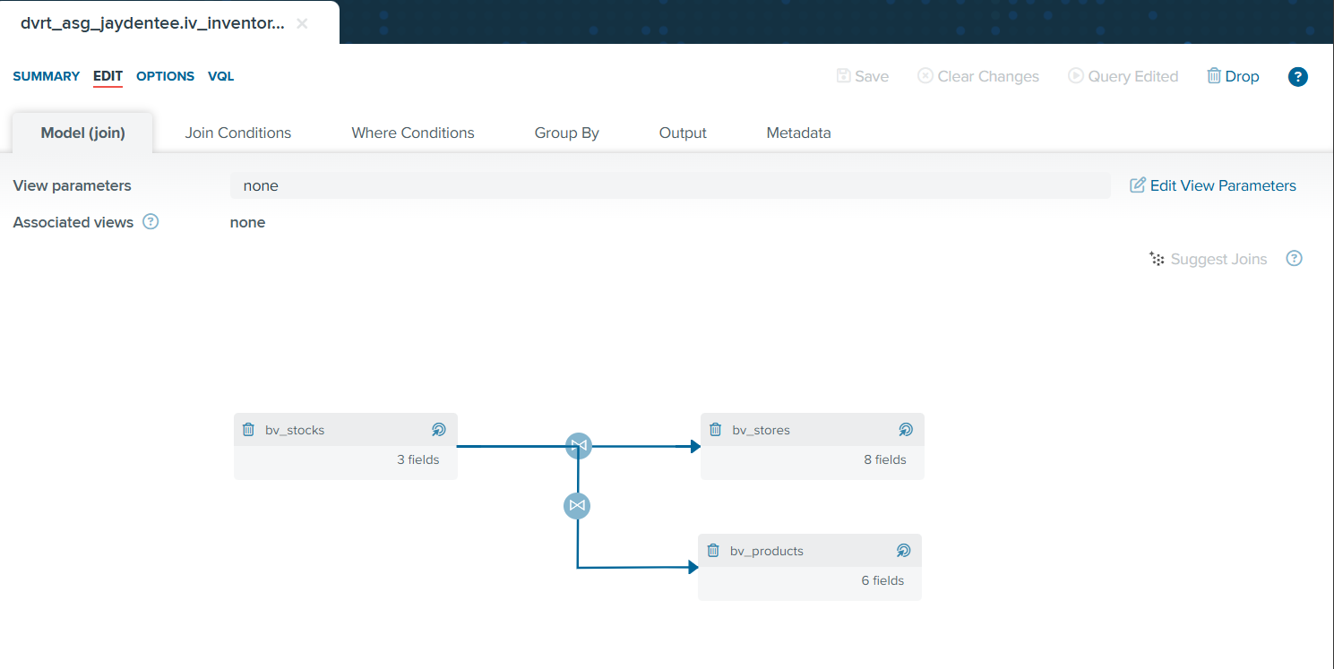
Figure 16. Join Model for iv_inventory_status

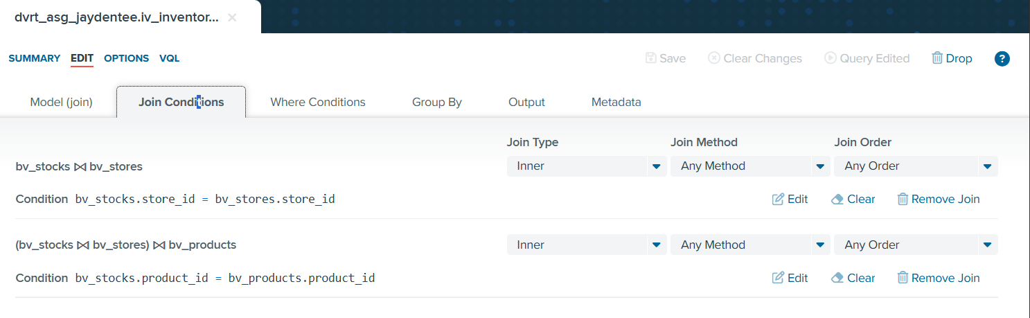
Figure 17. Join Conditions for iv_inventory_status

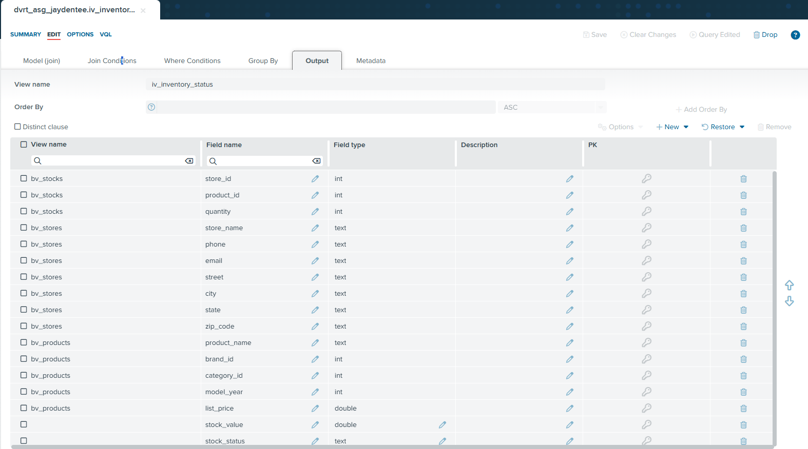
Figure 18. Output for iv_inventory_status

Iv_sales_enriched
Overview/Rationale
This view acts as the "Fact Table". It connects with the products, brands, and categories dimensions to resolve product details and the orders dimension to establish the timeline of transactions. Specifically, it joins the order_items table, which contains only product_id and quantity with the products, brands, and categories tables using Inner Joins, ensuring that every line item in a transaction is enriched with critical descriptive metadata.

Feature Engineering
status_description -> A user-friendly translation of the status database code (referred from kaggle)
- Formula => case WHEN (order_status = 1) THEN 'Pending' WHEN (order_status = 2) THEN 'Processing' WHEN (order_status = 3) THEN 'Rejected' WHEN (order_status = 4) THEN 'Completed' ELSE 'Unknown' END
- Reasoning => Improves the usability and adoption as ‘status’ was first an integar under the ‘Database code’ context hence it translates the integars to text. For example, “4” to “Completed”.

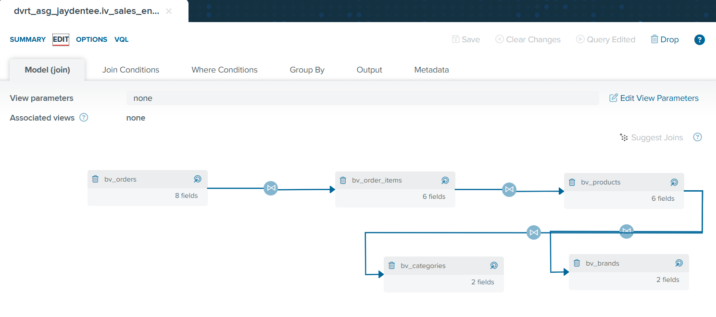
Figure 19. Join Model for iv_sales_enriched

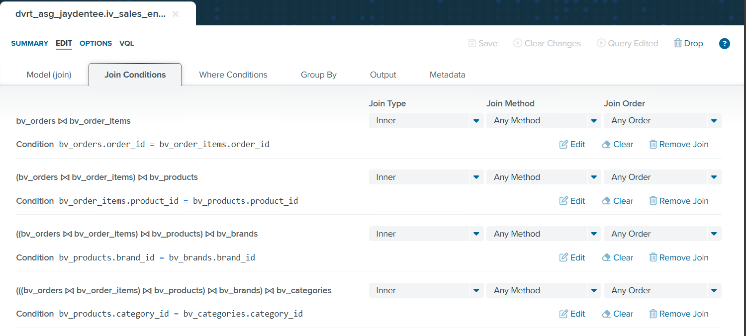
Figure 20. Join Conditions for iv_sales_enriched

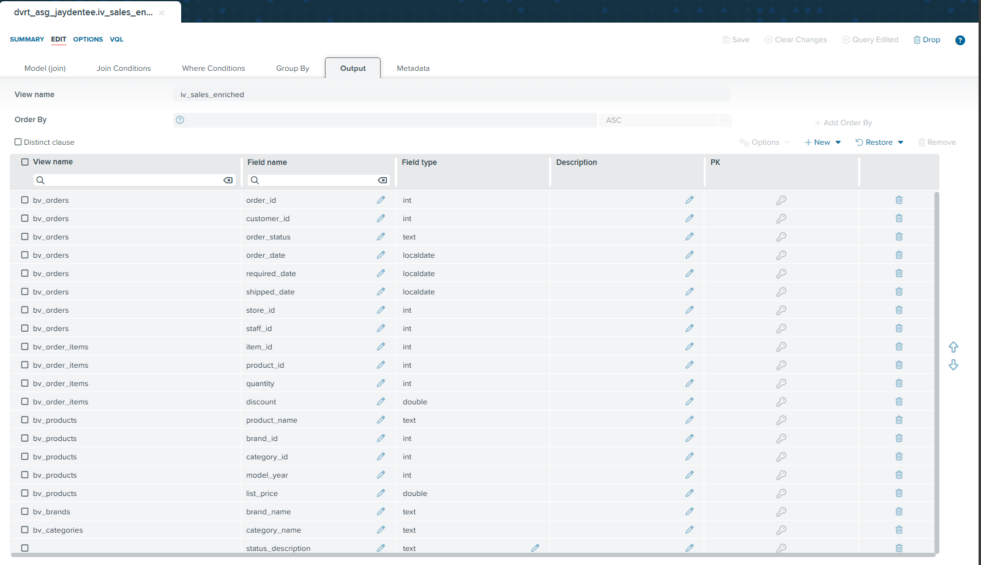
Figure 21. Output for iv_sales_enriched

Iv_sales_master
Overview/Rationale
This is the final integration step for the "Demand" side, designed to resolve the "Who" dimension. This view joins it with the customers and staffs tables, separating "Product Logic" from "People Logic". By joining customers and staffs here, we append demographic details (Customer City, Zip Code) and operational accountability (Staff Name) to the transaction. This results in a comprehensive sales master view that links revenue not just to a product, but to the specific employee who sold it and the customer who bought it.

Feature Engineering
net_revenue -> The true money made from a transaction, accounting for discounts.
- Formula => ((iv_sales_enriched.quantity*iv_sales_enriched.list_price)*(1-iv_sales_enriched.discount))
- Reasoning => The raw data only gave you "List Price". Hence, by engineering net_revenue, it reveals the actual profitability of the supply chain.

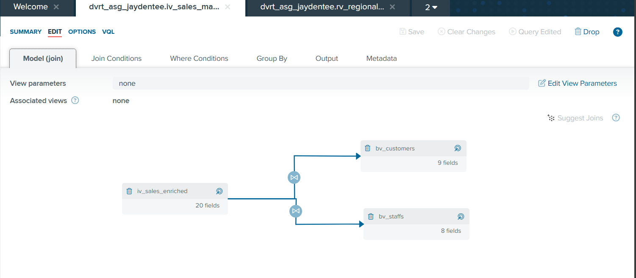
Figure 22. Join Model for iv_sales_master

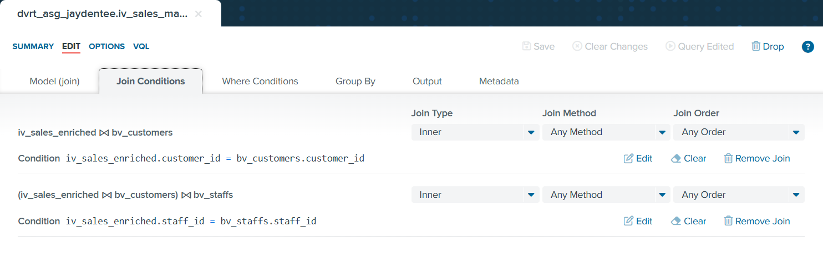
Figure 23. Join Conditions for iv_sales_master

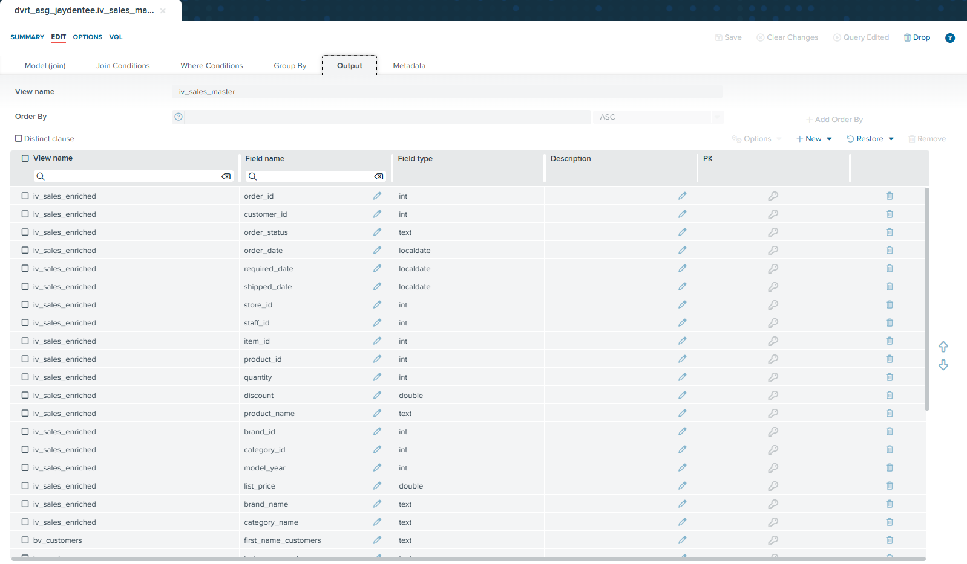
Figure 24. Join Model for iv_sales_master (Part 1)

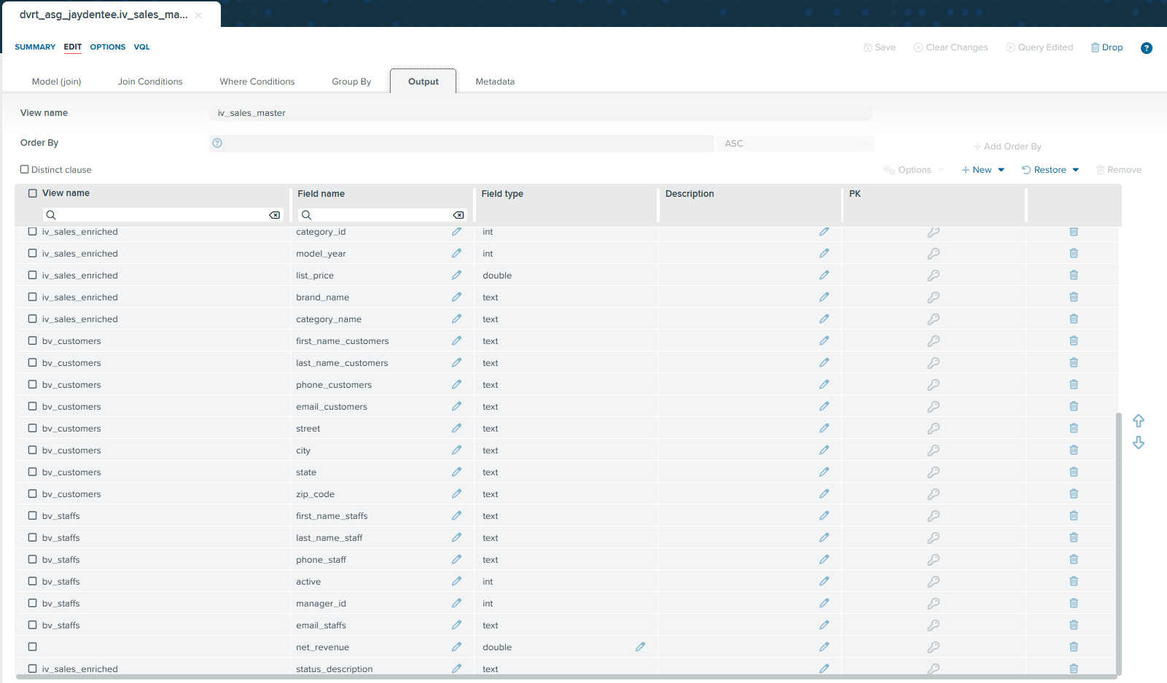
Figure 25. Join Model for iv_sales_master (Part 2)

4. Final Integrated View
The final report view, rv_regional_supply_chain (rv_*), was created as the business ready dataset for stakeholders analysis and reporting.


Figure 26. Finalized view folder to store rv_regional_supply_chain

rv_regional_supply_chain

Joining Logic
This view joins iv_sales_master and iv_inventory_status to strictly correlate sales velocity with shelf availability so as to adopt a complete ecosystem ingestion strategy. This is made possible by inner joining them via a composite key, product_id and store_id. By using an Inner Join ,we only analyzing products that strictly exist in both the inventory system and the sale master.

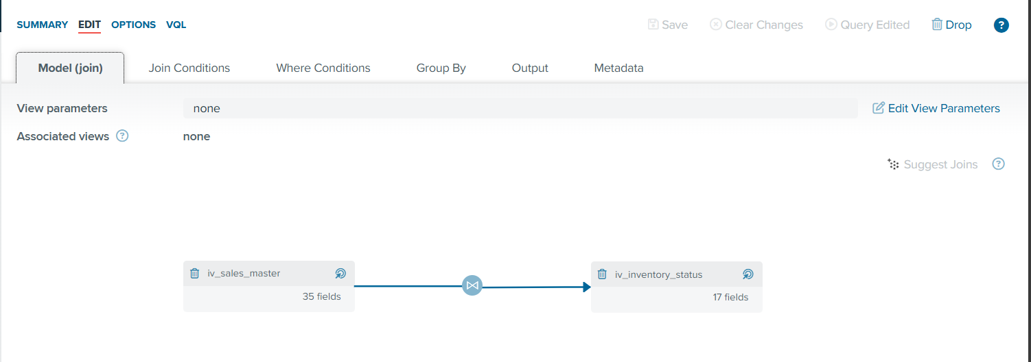
Figure 27. Join Model for rv_regional_supply_chain

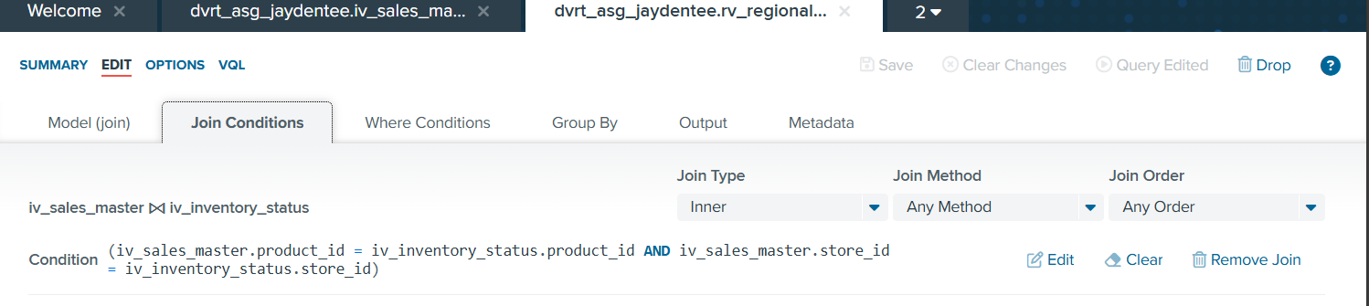
Figure 28. Join Condition for rv_regional_supply_chain

Contributing CSV file to final reporting view and Reasoning
The ‘rv_*’ acts as the convergence point for the entire database so as to answer the problem statement, hence the need to aggregate data from all 9 source CSV files is mandatory, ensuring no dimension of the business is left in silo.

I have also created a table, which explains the contribution that each csv have towards the finalized view. Additionally, I group certain csv together so as to interpret the contribution more clearly.
Groups | Source CSV Files | Contribution to Final View (rv_regional_supply_chain)
Demand Signal | orders.csv  order_items.csv | The Core Fact Table. Provides the transactional volume (sales_quantity) and pricing data required to calculate net_revenue. Without this, there is no measure of performance.
Supply Signal | stocks.csv | The Risk Counterweight. Provides the live inventory count (stock_quantity) per store. This is the only source of truth for calculating stock_status (e.g., "Out of Stock").
Product Dimensions | products.csv  brands.csv  categories.csv | Descriptive Metadata. Enriches raw IDs with human-readable names (e.g., "Trek", "Mountain Bike") and provides the model_year attribute essential for aging inventory analysis.
Regional Context | stores.csv | Geographic Granularity. Allows the analysis to be sliced by State, enabling the comparison of supply chain efficiency across different physical territories.
Customer Context | customers.csv | Targeting Logic. Provides the zip_code and city for every buyer. This is critical for mapping high-value customers against store locations to identify retention risks.
Operational Context | staffs.csv | Accountability. Links transactions to specific employees. While not used for inventory calculation, it ensures the view is future-proofed for sales performance by staff queries.

Dimension Design
The rv_* is aggregated by 22 key dimensions that enable comprehensive multi-dimensional analysis:
1. Dimensional Fields (Context & Grouping)
- store_name – Individual store performance tracking and regional comparison
- product_name – Identification of specific items for drill-down analysis.
- brand_name – For brand contribution analysis.
- category_name – To identify category-level demand patterns.
- model_year – Critical filter for identifying aging inventory.
- customer_city – Enables city-level market analysis and customer targeting.
- store_state – Geographic performance comparison at the state level.
- customer_zip_code – Precise location targeting for high-value customer proximity analysis.
- order_date – Supports time-series analysis for sales velocity trends.
- required_date – Benchmarks the expected delivery timeline to assess customer service promises.
- shipped_date – Tracks the actual fulfillment date to measure logistics efficiency and delays.
- first/last_name_staff – Enables operational accountability tracking per employee.
- product_id – Technical identifier used to uniquely distinguish specific items (SKUs) across the database.
- store_id – Technical identifier ensuring inventory is mapped to the correct physical location in join operations.

2. Metric Fields (Quantitative Analysis)
- stock_quantity – The primary supply metric, it measures physical inventory availability.
- sales_quantity – The primary demand metric, it measures transactional volume.
- list_price – Base value metric for determining "Premium" vs "Budget" product positioning.
- discount – Margin analysis, it reveals heavy discounting trends used to clear stock.

3. Engineered Fields (Derived Intelligence)
- net_revenue – Measures the true financial performance by accounting for discounts.
- stock_value – Quantifies financial liability by calculating total capital tied up in stock.
- stock_status – Immediate risk flag, it categorizes inventory into actionable buckets ("Critical", "Healthy", "Overstock").
- status_description – User-friendly filter,it allows analysis for different stock status.

How does these fields answer the exploratory question?

- "How does inventory sufficiency correlate with regional sales performance?"
The goal: Compare Supply vs. Demand by Region
Answered by: stock_quantity and stock_status (Supply) vs. sale_quantity, net_revenue (Demand), grouped by store_name, state, store_id, first_name_staffs, and last_name_staff (to rule out staff performance issues).
- "Which specific products and categories face the highest risk of 'Stockout' relative to their sales velocity?"
The goal: Identify items where Demand > Supply.
Answered by: sale_quantity filtered by status_description (Completed Orders only), compared against stock_status, grouped by category_name, product_id, and brand_name.
- "What is the volume of 'Aging Inventory' (older model years) across different regions?"
The goal: Find old bikes that are stuck on shelves.
Answered by: stock_value and stock_quantity filtered by model_year (e.g., < 2018), grouped by city and store_name.
- "How are high-value customers distributed across regions, and are they serviced by stores with adequate inventory levels?"
The goal: Map VIP locations against Store locations.
Answered by: net_revenue grouped by zip_code, city, and state, correlated with order_date vs shipped_date and required_date (to check if inventory shortages caused shipping delays).
- "Which brands demonstrate the highest 'Turnover Efficiency' per store?"
The goal: Calculate Efficiency Ratio per Brand.
Answered by: Comparison of sale_quantity to stock_quantity, analyzed alongside list_price and discount (to check if efficiency is driven by price cuts), grouped by brand_name.
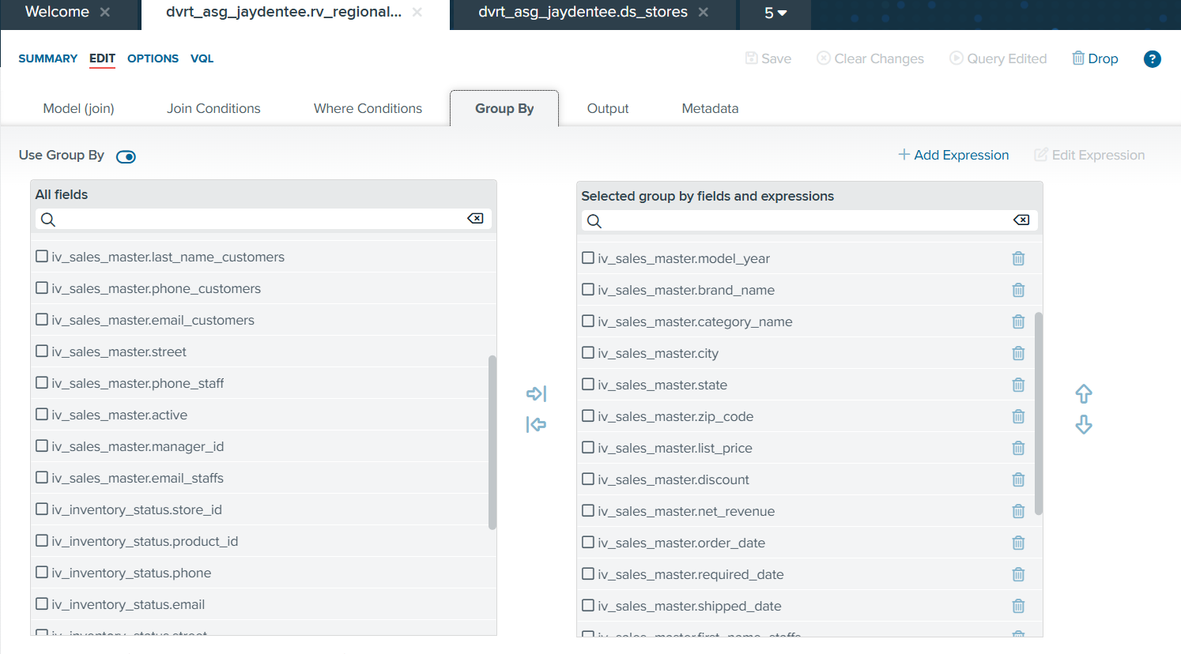
Figure 29. Group By for rv_regional_supply_chain

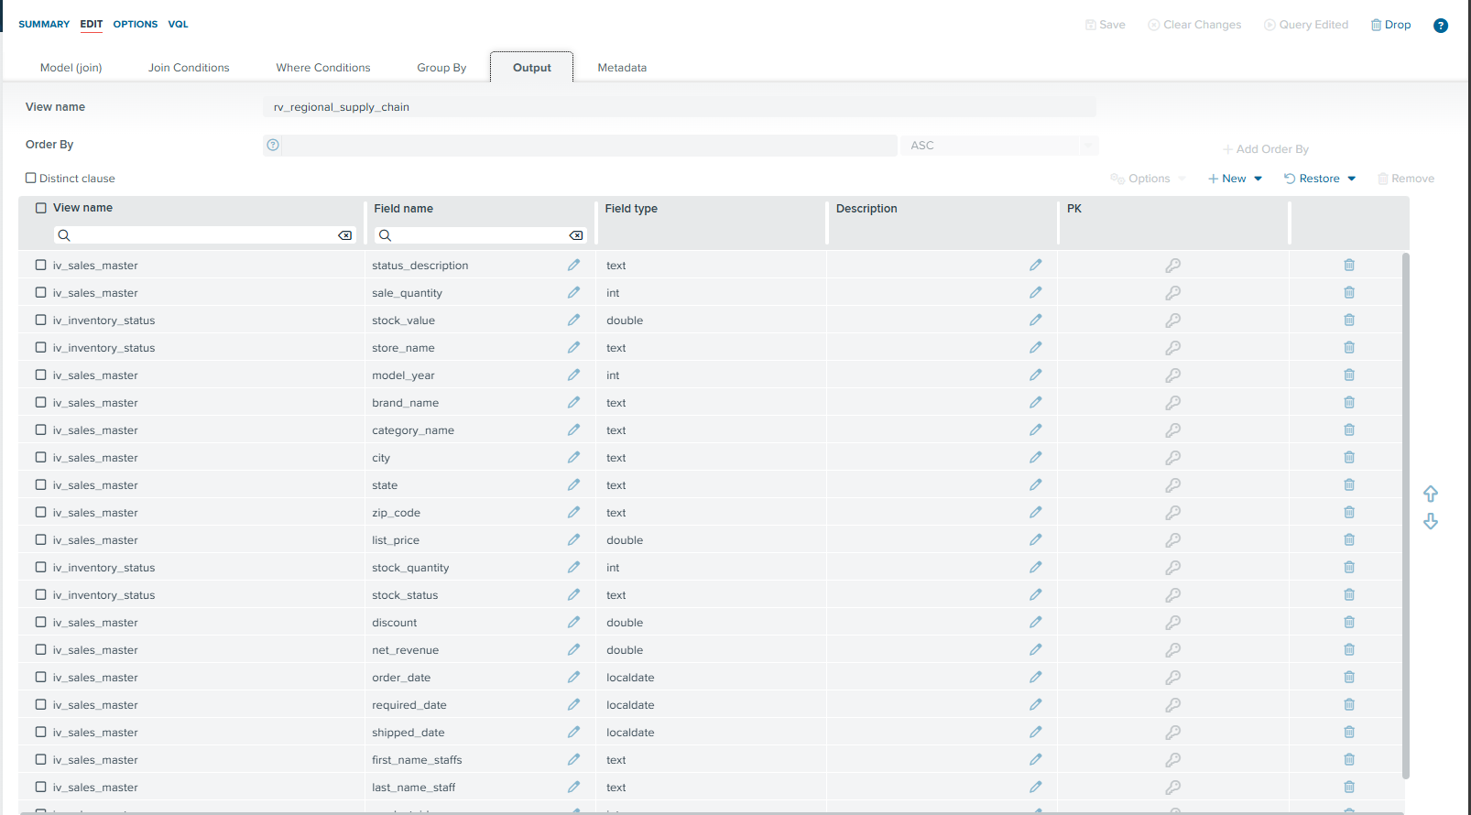
Figure 30. Output for rv_regional_supply_chain

5. REST or SOAP Deployment
To enable flexible data consumption by downstream applications and stakeholders, the finalized view was deployed as a REST web service (ws_regional_supply_chain) using Denodo’s data services function. This approach allows the consolidated data to be accessed in real time outside of Denodo.

Rationale of web service choice
Selecting REST over SOAP was a strategic architectural decision driven by the need for accessibility, performance, and ease of integration in a modern analytics environment.

1. Universal Compatibility (Ease of Consumption)
- The Problem: SOAP requires heavy XML parsing and strict WSDL contracts, which are difficult for modern BI tools like Tableau or PowerBI and web applications to consume.
- The REST Solution: REST uses standard HTTP methods (GET) and returns data in lightweight JSON or XML formats. This makes the ws_regional_supply_chain service instantly consumable by virtually any device, dashboard, or script like python without needing complex wrapper code.

2. Performance & Efficiency
- The Problem: SOAP messages are wrapped in a heavy XML envelope, increasing bandwidth usage and latency, which is a significant drawback when transferring large datasets like 2 years of sales history.
- The REST Solution: REST is stateless and supports lightweight JSON payloads. This significantly reduces the data overhead, ensuring faster query response times for stakeholders like the COO’s real-time dashboards.

3. Future-Proofing for Web Integration
- The Problem: In my problem statement, I imply a need for dynamic, potential web based reporting in the future.
- The REST Solution: REST is the standard for the web. By publishing as REST now, you allow the IT team to easily embed this supply chain data into a future web portal or mobile app for store managers, which would be much harder and clunkier with SOAP.

Summary:
REST was selected as the publication protocol to maximize compatibility with modern BI tools, reduce network latency through lightweight JSON payloads, and ensure the solution is future-proofed for potential web application integration.

REST Service Configuration
My REST web service (ws_regional_supply_chain) was created under 05_web_services to ensure clarity.


Figure 31. Overview for ws_regional_supply_chain

The finalized view (rv_regional_supply_chain) was used for the web service as it is business ready.

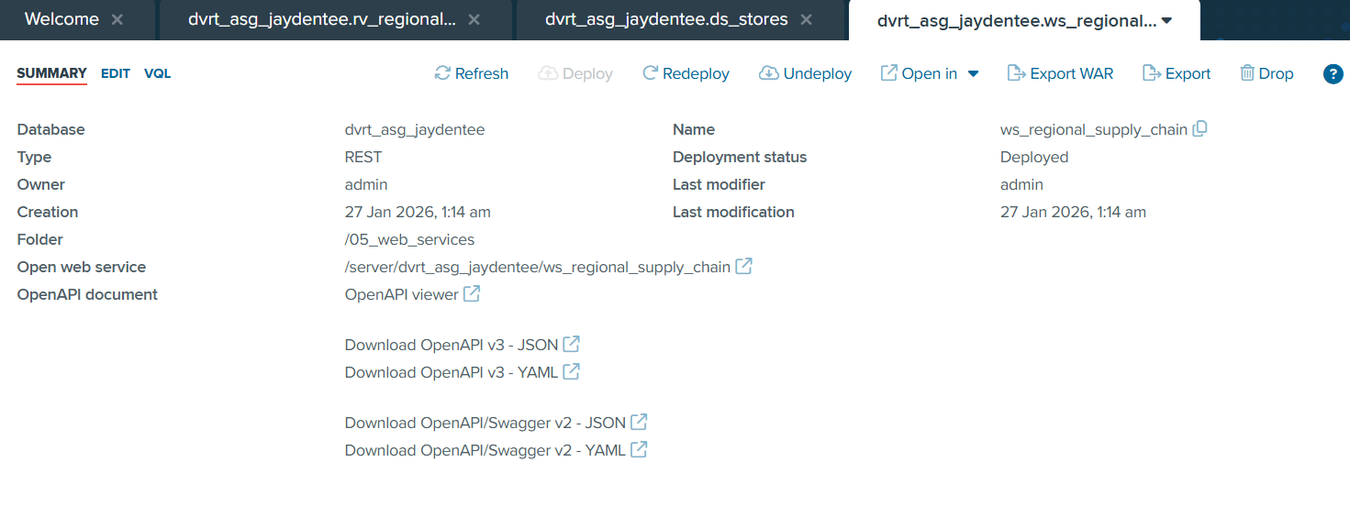
Figure 32. Summary for ws_regional_supply_chain

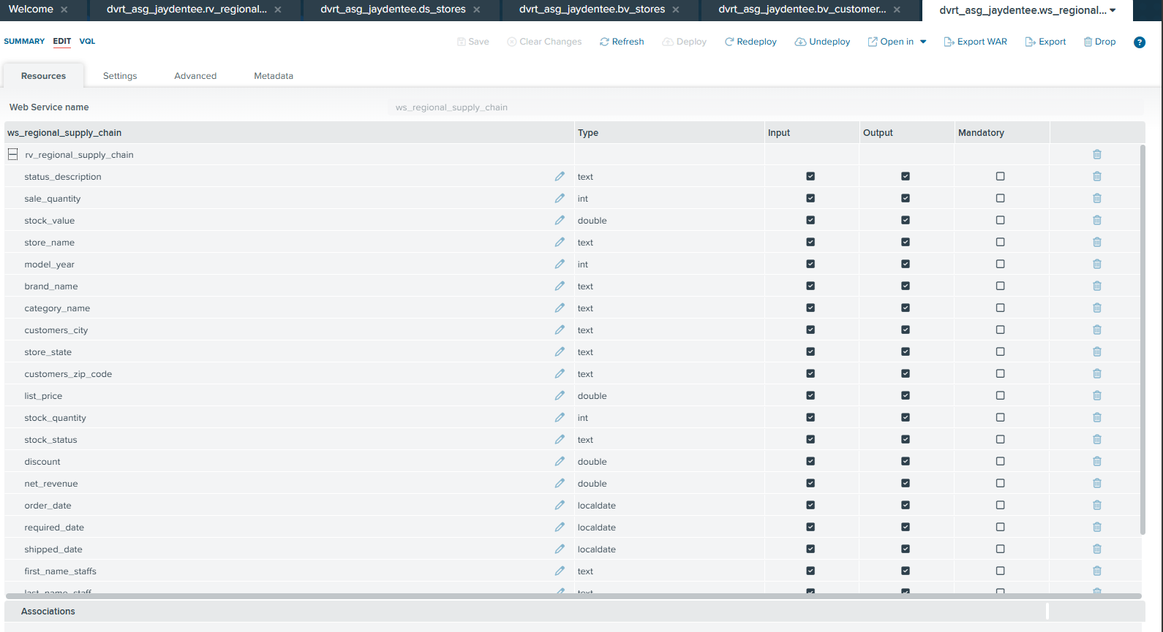
Figure 33. Resources for ws_regional_supply_chain

Web Service Configuration
The web sevice is also made available to HTML, XML and JSON representation but HTML is set as the defult representation.

Security
Under the setting section, the authentication method was set using HTTP basic with VDP, locking access control to Denodo’s server side security and ensuring only authenicated user with both the username and password can access the web service website, upholding proper data governance.
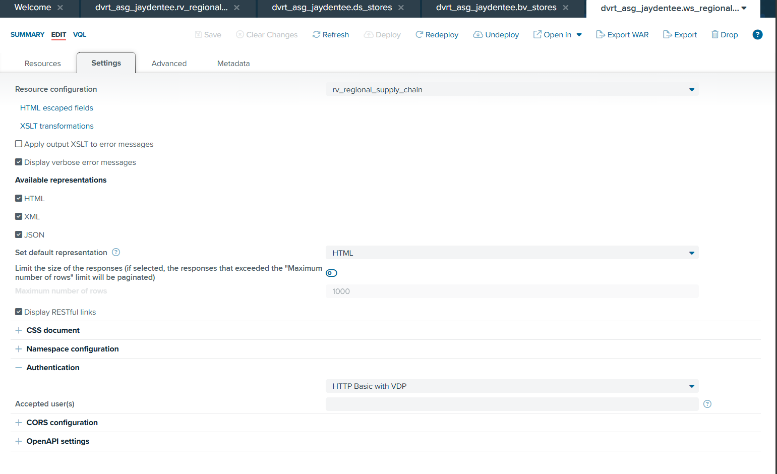
Figure 34. Authentication setting for ws_regional_supply_chain

Deployment of Service
After configurating the settings, the REST web service is deployed under the Web Service Containers interface. Where we have to first select the data base which ws_regional_supply_chain is. When it is deployed, under the Status column for the corresponding row ws_regional_supply_chain would be “Deployed” showing that is currently active
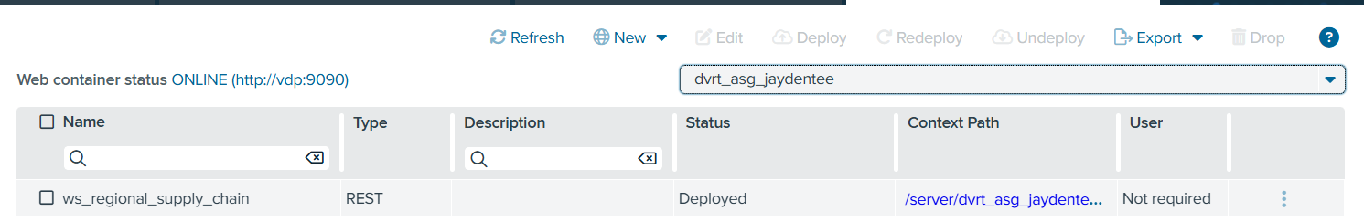

Figure 35. Deploying the REST web service

This is the authentication method being active and working
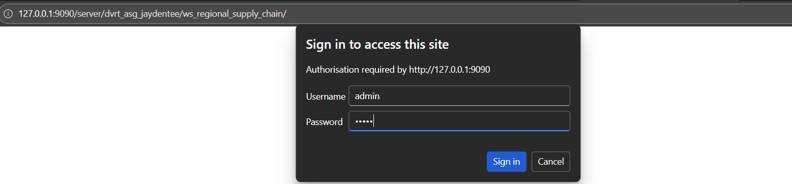
Figure 36. Login page when opening REST web service

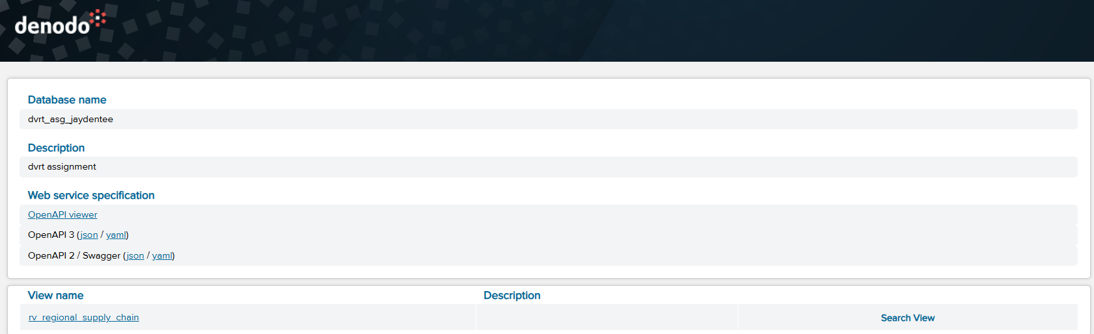
Figure 37. REST web service for ws_regional_supply_chain main page

Preview output
The data output is successfully integrated to the REST web service, where it returns the expected columns, row and data without duplicating or moving any underlying data. Hence it is now ready for business analysis for the stakeholders.
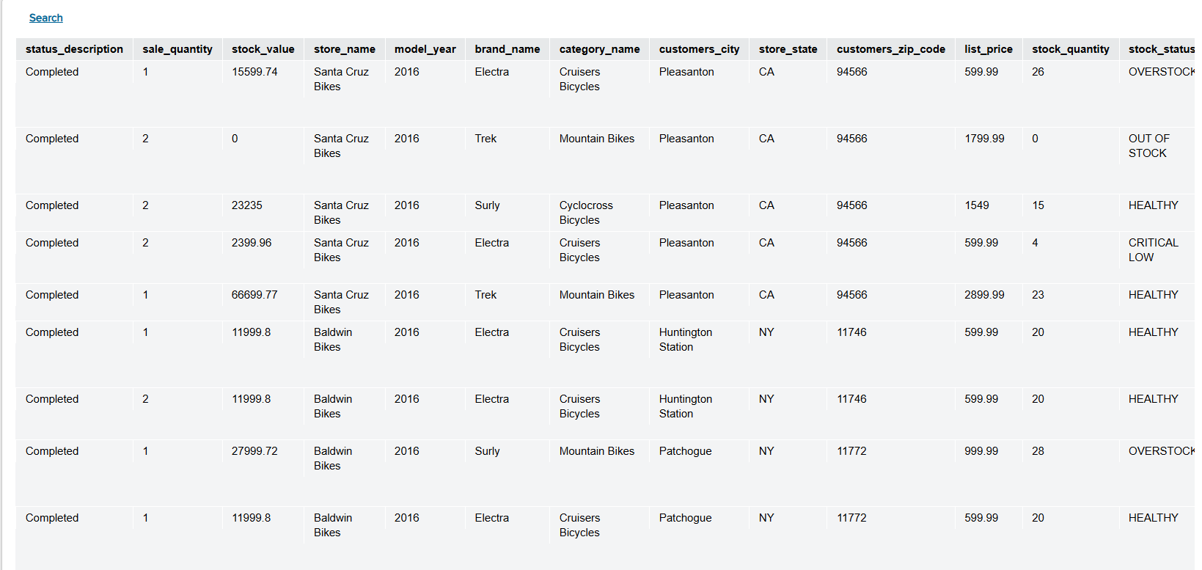
Figure 37. Preview for rv_regional_supply_chain through REST web service

6. Summary and Further Improvements

Summary of Findings
This project successfully addressed the "operational blind spots" identified in the value-based problem statement by establishing a unified, virtualized supply chain view. By integrating nine disparate CSV sources into a single rv_regional_supply_chain dataset, the solution successfully correlates Demand (Sales Velocity) with Supply (Inventory Levels) at a granular store-product level.

The implementation of engineered features, specifically stock_status and net_revenue, transformed raw technical data into decision-ready insights. Stakeholders can now instantly identify "Aging Inventory" liabilities and prevent regional stockouts without manual cross-referencing. The successful deployment of the ws_regional_supply_chain REST web service ensures that this intelligence is no longer locked in static files but is available for consumption by modern BI tools or web applications, bridging the gap between IT data storage and Executive decision-making.

Reflection on Deployment
The deployment phase demonstrated the transition from a theoretical model to a live operational tool. By publishing the rv_regional_supply_chain view as a REST Web Service (ws_regional_supply_chain), the solution successfully bridged the gap between raw database storage and end-user consumption.

Configuring the HTTP Basic Authentication with VDP ensured that while the data is easily accessible via a URL, it remains governed and secure. The successful preview of the JSON output verified that the virtualization layer correctly handles the request-response cycle, delivering the unified supply chain data to any external application or dashboard without the need for physical data replication.

Key learning outcomes
A key learning outcome was understanding how Denodo supports "logical integration", which is joining and transforming data without physical movement. Building the integrated layer reinforced the importance of:
- Selecting the correct grain: Aligning the "Transaction Grain" (Sales) with the "Store-Product Grain" (Inventory) by implementing a composite join key (product_id + store_id) to ensure accurate correlation.
- Enforcing consistent datatypes: Ensuring strict data type consistency for join keys across disparate CSV sources to guarantee the integrity of Inner Joins.
- Deriving business metrics in the right layer: Calculating net_revenue and stock_status within the virtualization layer rather than the BI tool, preventing duplicated or conflicting calculations.
- Understanding aggregation trade-offs: Balancing the granularity required for detailed operational analysis (e.g. Staff Performance) against the high-level grouping needed for regional reporting.

Further Improvements
While the current solution is robust, I have identified some enhancements, which would increase my assignment quality :
- Implementation of Row-Level Security (RLS): To enhance data governance, RLS should be implemented to restrict access based on user roles. This would ensure strict privacy by limiting stakeholders (e.g., Regional Managers) to viewing only the data relevant to their specific territories.
- Performance Optimization via Caching: Enabling 'Cache Mode' in Denodo would allow the system to serve pre-computed snapshots of the data. This ensures sub-second query performance and reduces load on source systems as historical datasets expand over time.
- Transition to Real-Time Data Sources: Future iterations should replace static CSVs with live JDBC connections to enterprise ERP databases. This would upgrade the solution from a historical analysis tool to a live operational monitor, enabling immediate reaction to inventory shifts.

